**Lab 2:**

**Step 1: Install and Configure Ingress Controller**

1. Install an Ingress Controller such as Nginx Ingress or Traefik in your Kubernetes cluster.

We need to install Helm to install Nginx Ingress, which is the Kubernetes package manager

After installing Helm we want to run the following commands to install ingress

1st we want to create a namespace:



2nd we want to add the ingress-nginx to the local repository:



3rd we want to update our local repository:

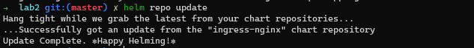

Finally, we will install ingress-nginx in our newly created namespace:

Check that the Ingress controller pods are running:

1. Configure the Ingress Controller to handle incoming HTTP/HTTPS traffic and route it to the appropriate services.

In the below script the traffic flow will be divided between the paths **/v1** and **/v2**.

Each path when pinged will redirect the traffic flow to the application associated with it.

